### Miniature House Pattern #1 - A Simple Rectangular House

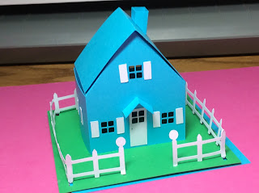

I am going to make a series of miniature houses. Here is the first one. I used card stock to make it. I might add glitter later to make a Christmas village or add more embellishments. For now, I am going to make the basic house.  
  
This design is also a box. The tab can be glued down if you do not want the box feature.